17.70: a) The heat current will be the same in both metals; since the length of the copper rod is known,

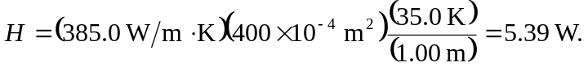

b) The length of the steel rod may be found by using the above value of in Eq.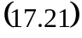 and solving for 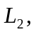or, since  are the same for the rods,

